One benefit of time-frequency analysis over a traditional waveform is that it allows us to see more easily the presence of a variety of instruments or voices. Take, for example, the track “Wake Up” from the Free Music Archive.

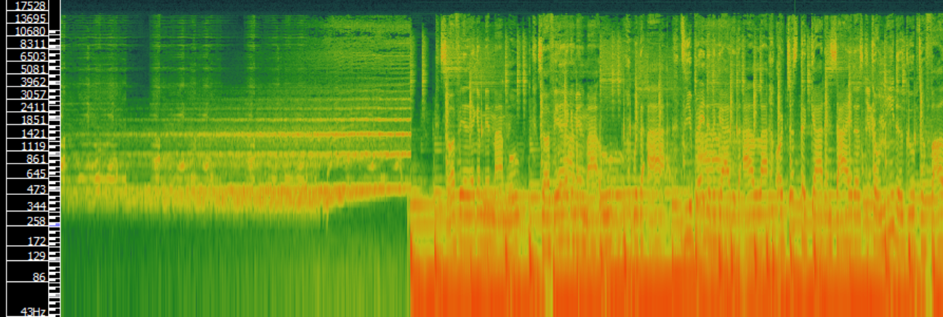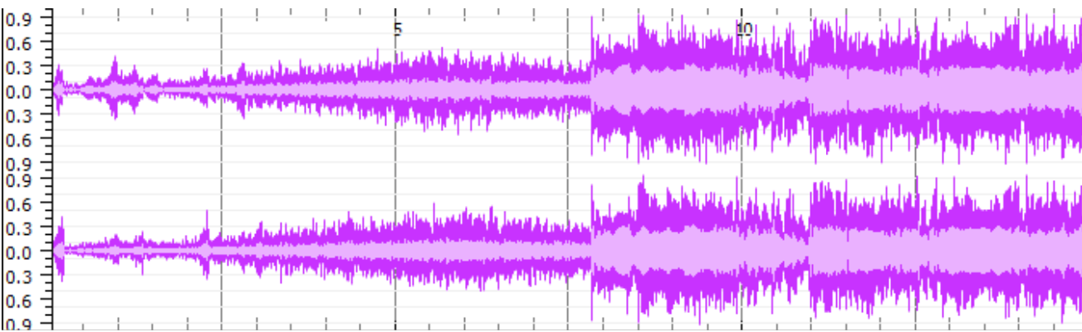

This portion shows the intro of the track moving into the first verse. While both visualisations indicate a change in sound at the end of the intro (around the 7 second mark), the time-frequency analysis indicates this more clearly. It also shows that the change in sound involves a change in the level and density of the frequencies via many orange tones in the visual. This can suggest the presence of multiple instruments or voices – which cannot be seen in the waveform. The waveform analysis – when viewed at this level – can show changes in volume clearly and when zoomed in to view in closer detail it may reveal pitch information – although this is extremely difficult to understand by eye alone.